
Operational Planning And Control

1. Introduction
1.1 Purpose
The purpose of this document is to outline the operational planning and control processes required to meet the information security requirements of ABC-FinTech. These processes are designed to ensure that all security controls and actions are implemented and managed effectively.
1.2 Scope
This document applies to all processes, departments, and personnel within ABC-FinTech that are involved in the Information Security Management System (ISMS). It also includes controls for outsourced processes that have an impact on information security.

2. Operational Planning and Control Process
2.1 Planning and Implementing Information Security Processes
ABC-FinTech plans, implements, and controls processes to meet the following information security requirements:
- Ensuring the confidentiality, integrity, and availability (CIA) of information assets.
- Complying with ISO 27001:2022 standards and other regulatory requirements.
- Managing risks identified in the risk assessment.
- Achieving the information security objectives as outlined in the Information Security Objectives document.
2.2 Documented Information for Process Control
ABC-FinTech retains the necessary documented information for each process to ensure that they have been carried out as planned. This includes:
- Process flow diagrams.
- Audit logs.
- Change management records.
- Security incident response logs.
2.3 Controlling Changes and Mitigating Adverse Effects
ABC-FinTech ensures that all changes to information security processes are planned and controlled. Unintended changes are reviewed, and appropriate actions are taken to mitigate any negative impacts on the ISMS.

3. Process Diagrams
3.1 Process 1: Risk Management and Control Process
The following diagram outlines the steps involved in the risk management process, from risk identification to treatment and monitoring.

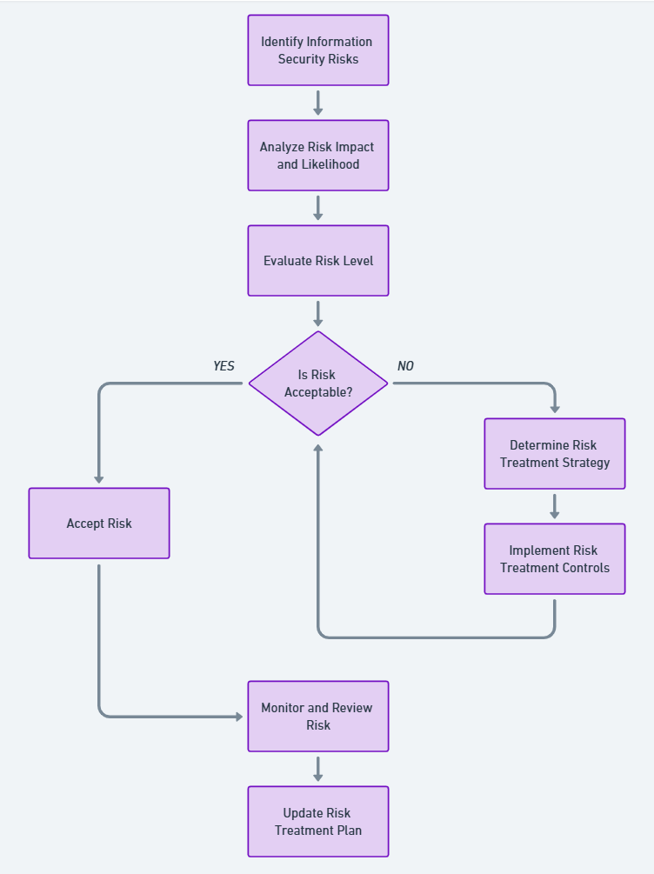

3.2 Process 2: Change Management Process
The following diagram outlines the steps to manage and control changes to security processes or infrastructure, including reviewing unintended changes.
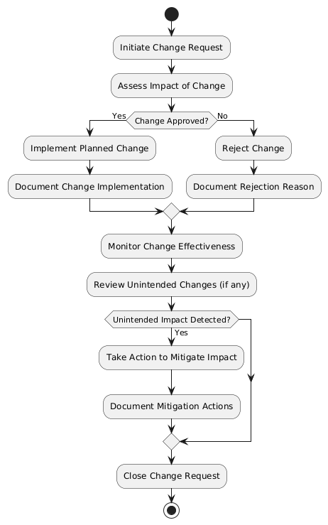

3.3 Process 3: Incident Response and Mitigation Process
The following diagram describes the steps for managing security incidents, from detection to mitigation and review.
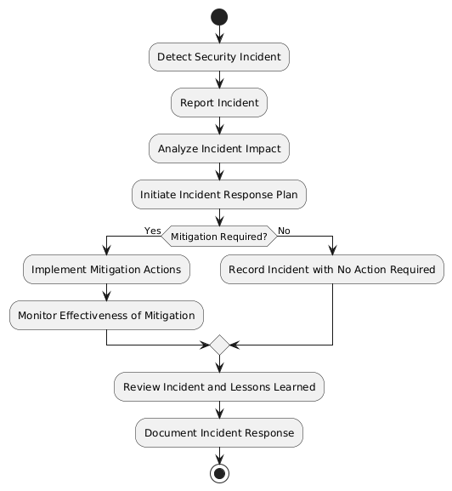

4. Controlling Outsourced Processes
4.1 Identifying Outsourced Processes
ABC-FinTech identifies and documents all outsourced processes that impact the ISMS. These include:
- Cloud service providers.
- Payment processing vendors.
- Third-party security monitoring services.
4.2 Controlling Outsourced Processes
ABC-FinTech ensures that outsourced processes are controlled by:
- Incorporating security requirements into contracts with vendors.
- Conducting regular security audits of third-party providers.
- Requiring compliance with relevant security standards (e.g., ISO 27001, PCI DSS).

5. Monitoring and Review
5.1 Regular Reviews
All information security processes are reviewed regularly to ensure that they are being carried out as planned. This includes:
- Monthly internal audits.
- Quarterly reviews of risk management and change management processes.
- Annual review of incident response procedures.
5.2 Documentation and Evidence
ABC-FinTech maintains the following documentation as evidence of effective process implementation:
- Change management logs.
- Security incident reports.
- Risk management records.
- Vendor audit reports.

6. Conclusion
This document defines the operational planning and control processes needed to meet ABC-FinTech’s information security requirements. By following these processes and retaining documented information, ABC-FinTech ensures that its ISMS is effective and compliant with ISO 27001:2022 standards.

Approved by:
CEO, ABC-FinTech
Date: 19 Jan 2024

